Aaron Owens

Interview Questions

2/12/19

Interview 1

Q1-How much bandwidth will you need for each of the six locations? (Upper and lower limit of frequency)

S-Mart needs to find the best bandwidth option for our company needs. If we fail to provide the correct amount of bandwidth, we will have an underperforming website. Right now we need to maximize the amount of bandwidth, because we plan to see a high increase in traffic. My estimation is 175-200 Gigabytes per month. 3,000 visitors per day 1 megabyte per page

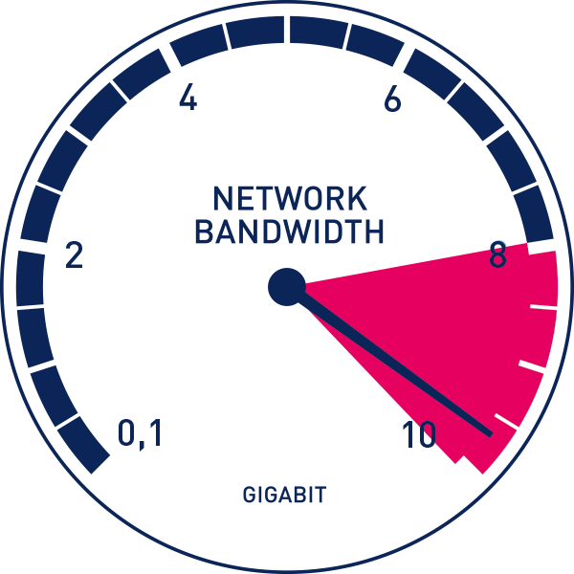

Q2-Describe S-Marts new topology plans? (Physical layout of the computer network)

Our goal is to reach- principles of hierarchy, modularity, resiliency and flexibility. Cisco’ three-tier hierarchical model will help our company reach our goals.

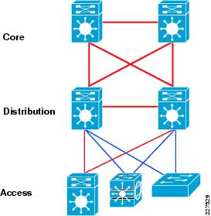

Q3-What’s your plans to upgrade routers for each location?

Right now we are using cisco 1800 series routers, which are great for 25 or less employees. This router is perfect if all you need is a router to connect your office to the internet, VPN, firewall, and wireless, however with our company growing we will need to upgrade to the 2800 series. Each location will be equipped with these top of the line routers. These routers give you everything the 1800 does, plus redundant power supply options, Gig-Ethernet ports, Network Module (NM) expansion slots, VoIP. These are all the features we need to take our company to the next level.

New Features 2800 series

Provides service for 100+ workers

Provides wireless networking for employees

Advanced communication for VoIP calls to other stores.

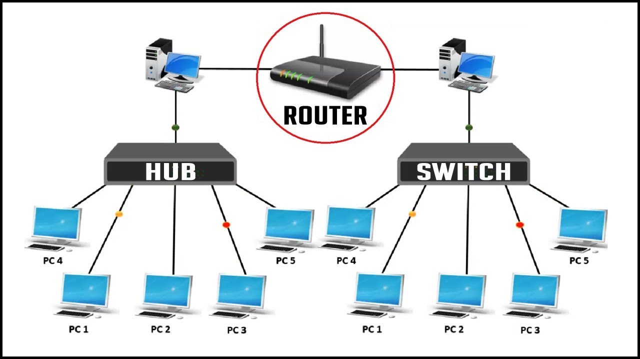

Q4-Do you have plans to upgrade your NIC for each new device? (Network Adapter)

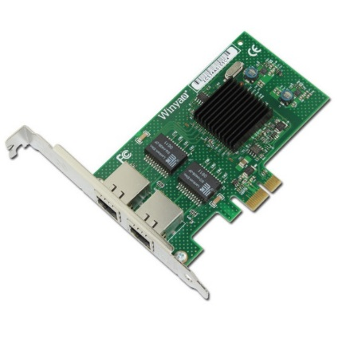

Q5-What is your budget to upgrade VPNs for each location? (Virtual Private Network)

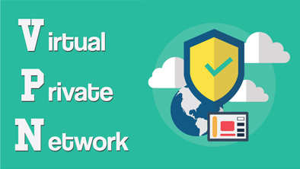

Q6-Are you planning on switching out every Hub for a router for each location? (Hub least expensive, least intelligent,)

We all know a hub and a switch are two different devices. Our company wants to switch out hubs for switches because of security issues. Hubs are the more affordable options, but they create security risk factors. Right now S-Mart needs to take all precautions to avoid any security problems, especially when we are about to expand.  Switches operate at the data link layer (layer 2) and sometimes the network layer 3. Hubs connect segments of a LAN. It contains multiple ports so when a packet arrives at one port, it is copied to the other ports so that all segments of the LAN can see all packets. You can see how hubs can be a honeypot for hackers. The big difference between these two devices is in the method in which frames are being delivered. Hubs share bandwidth and S-mart simply needs to move away from these devices.

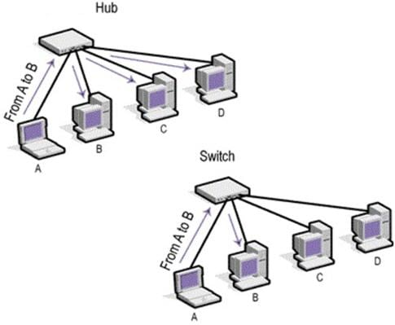

Q7- Tell me about your plans to go from multiplexing to multi-accessing?

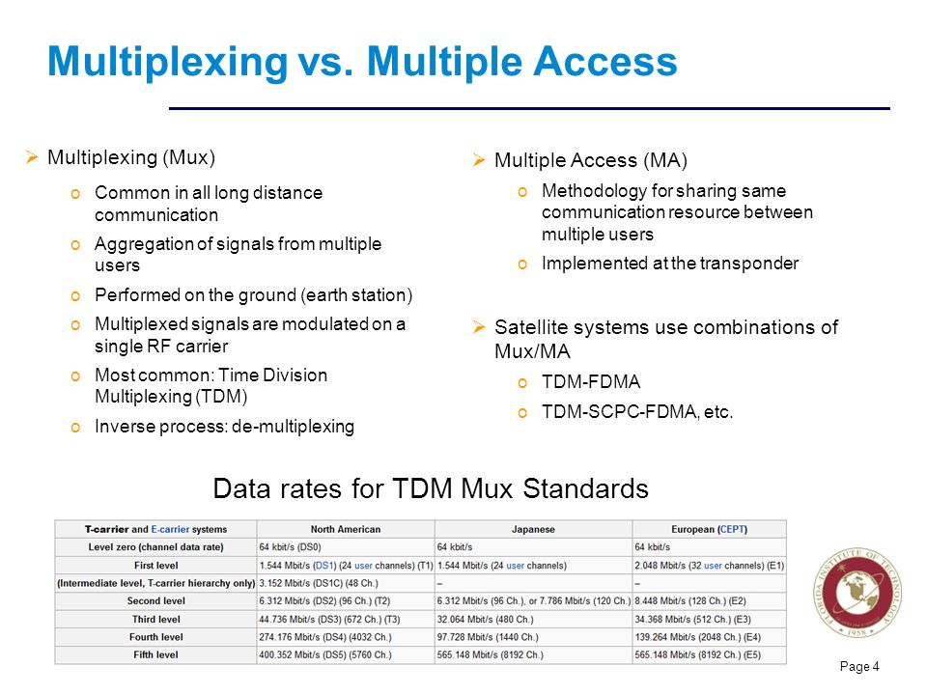

Q8-What are your plans to make the new network more effective and efficient?

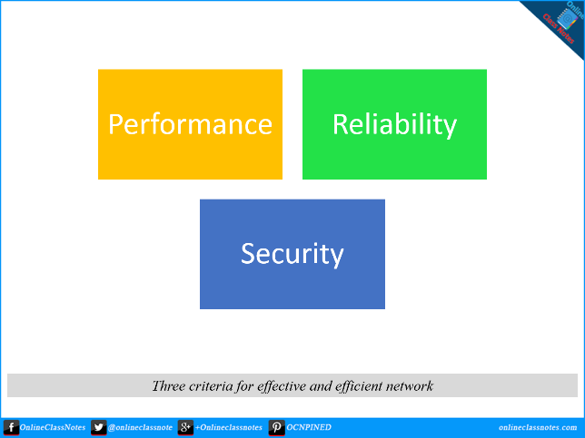

Q9- What are the 3 major protocols you will be using for your new network?

S-Mart will be using the most common protocols, however we will be adopting newer more efficient protocols.

**Internet Protocol-**The Internet Protocol is where it all begins. IP is responsible for basic networking. The core of the IP protocol works with Internet addresses and every computer on a TCP/ IP network must have a numeric address.

**FTP File transfer Protocol**- FTP can be defined as a standard network protocol which is especially used to transfer files from one host (machine/ operating system) to another host over a TCP/ IP based network. Typically FTP is used to push files up or down to a server.

**SSH Secure Shell**- SSH allows for remote command-line login and remote execution. It has many of the functions of FTP but is more secure. The latest versions are referred to as SSH-1 and SSH-2.

S-Mart will adopt IMAP4 and discontinue POP3. Our company will inherit HTTP protocol, because this aligns with social media/marketing

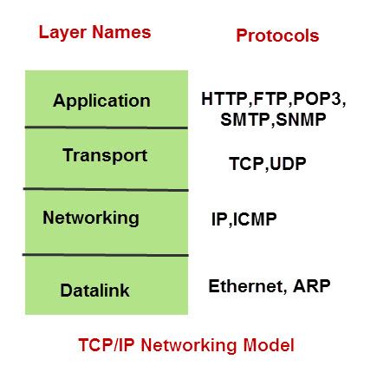

Q10- What are your plans to upgrade from anti-virus to a firewall? (Explain)

S-Mart started off as a small company and only needed anti-virus software. It is vital that all locations upgrade to a complete firewall. **Antivirus** protects users from lingering, predictable-yet-still-dangerous malware. Whereas, a **Firewall** is a software program that prevents unauthorized access to or from a private network. We need this security to keep malicious hackers out of our system. Firewall acts as a barrier for the incoming traffic to the system, and this is exactly what we will need with all the new traffic from customers. Right now we are in the beginning stages of finding the packet filtering firewall.

